Chapter 3 p.72

Most targeted sectors by North Korea

North Korea is particularly interested in spying on institutions and individuals that study North Korea itself.

Pie chart showing percentages of the most targeted sectors by North Korea. It shows A. Think tanks/ NGOs: 23%, B. Education: 22%, C. Government: 11%, D. Finance: 9%, E. Inter-Government Organization: 6%, F. IT: 5%, G. Media: 4% H. Defense Industry: 3%, I. Manufacturing: 2%, J. Transportation: 2%, K. Food Agriculture: 1%, and L. Other: 12%.

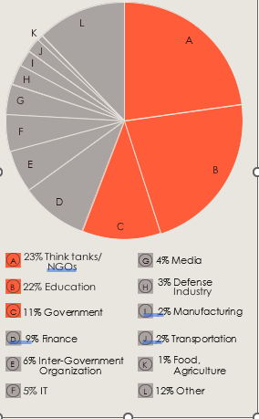

Source: Microsoft Threat Intelligence nation state notifications